PAMELA R. LAMPITT  Chair  ANGEL FUENTES  Vice-Chair  GARY S. SCHAER  BENJIE E. WIMBERLY  CAROLINE CASAGRANDE |  | 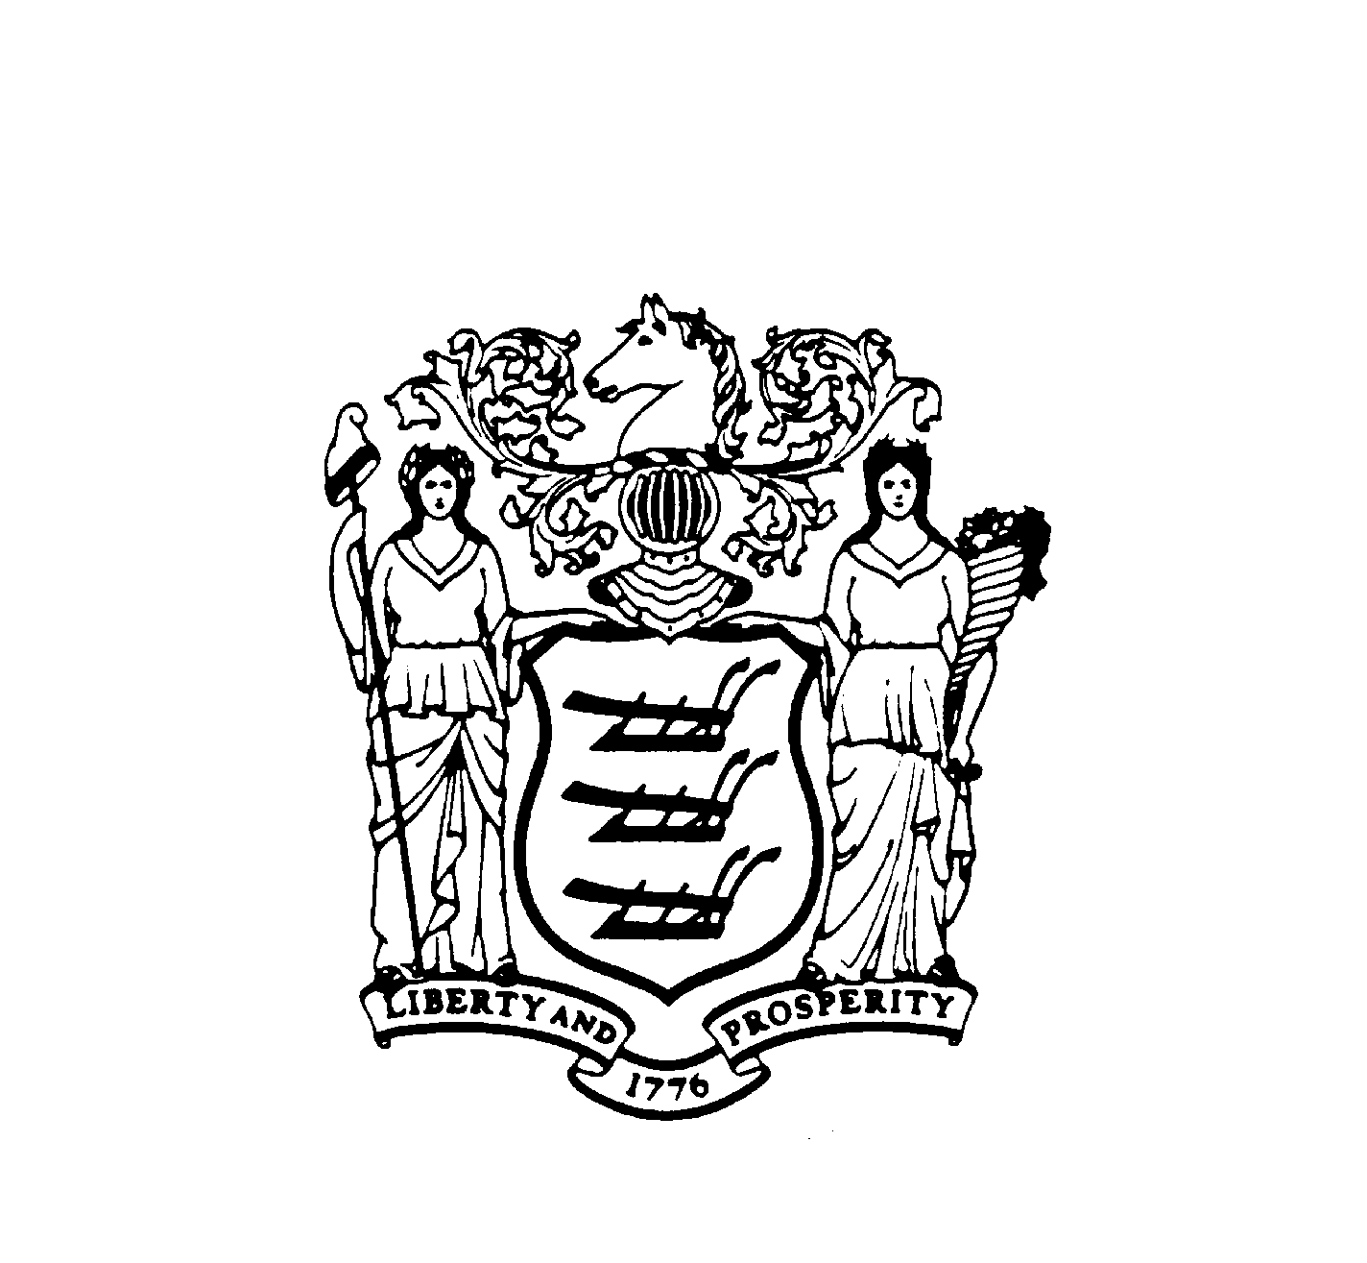 |  | MICHELE LEBLANC  Office of Legislative Services  Committee Aide  (609) 847-3860  (609) 943-5996 fax
N e w J e r s e y S t a t e L e g i s l a t u r e
ASSEMBLY WOMEN AND CHILDREN COMMITTEE
STATE HOUSE ANNEX
PO BOX 068
TRENTON NJ 08625-0068

February 2, 2012

John Sarno
President
Employers Association of New Jersey
30 W. Mount Pleasant Avenue, Suite 201
Livingston, New Jersey 07039

Dear Mr. Sarno:

The Assembly Women and Children Committee is meeting on Monday, February 6, 2012 at 10:00 AM in Committee Room 16, 4th Floor, State House Annex, Trenton, New Jersey to receive testimony from invited speakers concerning the gender earnings gap and pay equity and how these issues affect women in the State of New Jersey.

We are inviting you to present testimony to the committee on these issues. Please provide 10 copies of any written testimony you wish to submit to the committee. If you are unable to attend, please contact the Committee Aide, Michele Leblanc at (609) 847-3860.

Thank you for your attention to this letter and we look forward to hearing from you on February 6, 2012.

Very truly yours,

Pamela R. Lampitt
Chair

PRL/ml
/tmp/in/input.doc

